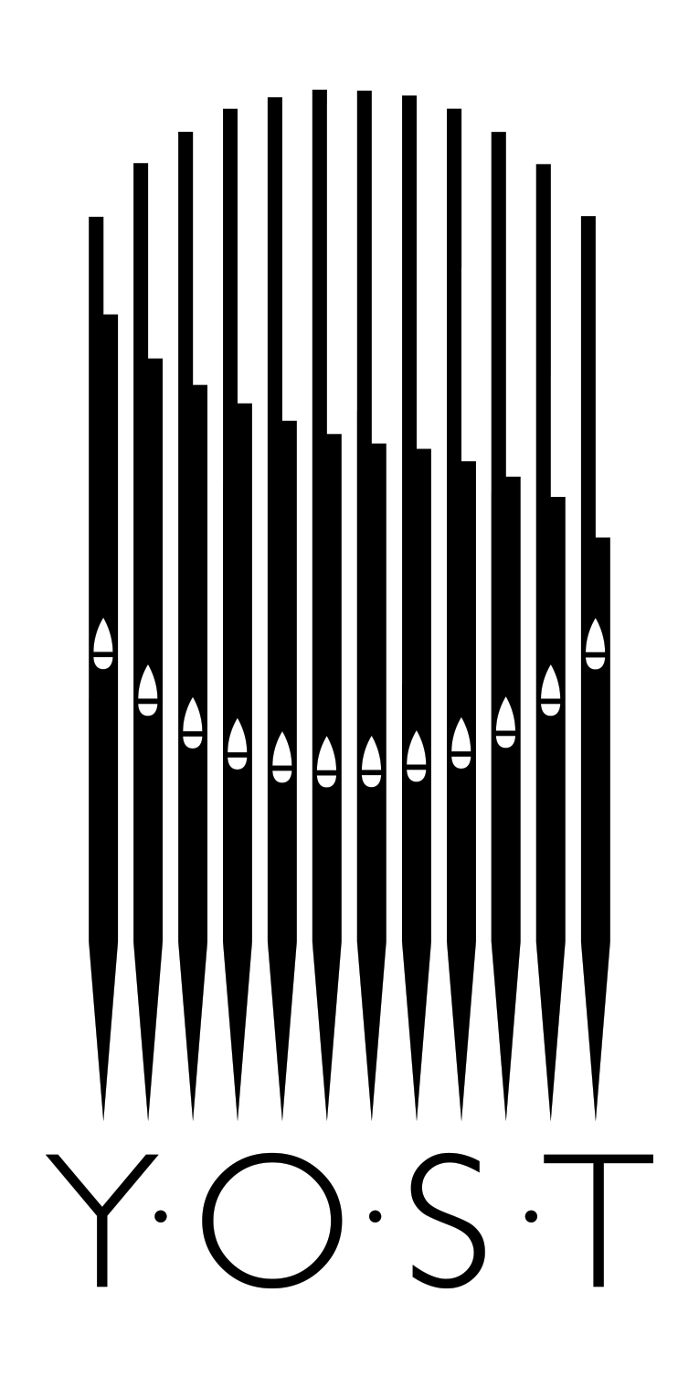
The Young Organ Scholars Trust (YOST)
Application for Funding

To be completed by the Parent/Guardian in respect of all children under the age of 18
Fields with a * are required.

Section 1: Personal Information____________________

Surname*

Forename(s)*

Nationality*

Date of Birth (DD/MM/YYYY) *

Permanent Address of Student*
(or of parent/guardian for students under 18)

Address for communication purposes:
(if different from above)

Parental Telephone*

Email for Correspondence*

Parent/Guardian’s Name(s)*

**Please note that for all students under 18, we must have a parent’s email address.

Section 2: Education________________________________

Name of School *

Current Year of the student *

Qualifications obtained (or being sought) and course(s) being followed?
Please state dates if known

Section 3: Organ Studies___________________________

For how long have you studied the piano/organ? *

What are your medium/long-term goals as a musician?

Name of Teacher*

Teacher’s Telephone*

Teacher’s Email:

Last organ and/or piano grade taken (if applicable) *

Mark/Percentage*

Examination Board*

Date of Examination (dd-mm-yyyy):

Other information relevant to your musical education and experience
e.g., attendance at Choir/Saturday Music School, Junior College Music Programme, choirs,
orchestras, music festival, competitions, organist’s posts etc:

Section 4: Financial Information_______________________________

Are you applying for any other forms of funding, grants, or bursaries to help pay for organ lessons? If so, please state the amount you are seeking and please provide full contact details of the funding body.

Please provide any other financial details which you would like us to consider
e.g., single parent, unemployment, ill health, debt, other
children & their education:

_________________________________________

Income:

Please supply details of your family’s income.

1st Parent’s Salary: * £
2nd Parent’s Salary: * £

Please enclose with your Application a photocopy of a recent P45 Form and/or other relevant document(s) as evidence of income. We shall treat such documents in the utmost confidence and destroy or delete any information submitted after a decision has been made.

Other income (e.g., benefits, child maintenance, pensions, bonuses, dividends, student grants, student loans) *

Other income (e.g., benefits, child maintenance, pensions, bonuses, dividends, student grants, student loans) plus any Music/School scholarships/bursaries*

Total family income: £

Section 5: Referees_______________________________________

Please provide the names and full contact details of two referees that may be contacted. One of the referees should be a teacher at the student’s present school i.e., music/form teacher. In the case of a home-schooled applicant, one reference should come from a
professional music teacher.

Referees should not be members of your family circle.

1./

2./

I hereby declare that the information provided is true and correct. I understand that the giving of false information will lead to the refusal/withdrawal of the application/scholarship.

Parental Signature……………………………………………………… Date……………………………………………………

By completing this form, we have your consent to provide you with the requested information in relation to the YOST’s activities. In accordance with the Regulation (EU)
2016/679 of the European Parliament and the Council on the protection of individuals with regards to the processing of personal data you have the right to access the information
that concerns you (Article 15), amend if incorrect (Article 16), eliminate (Article 17), limit use of (Article 18), portability (Article 20)

Once completed, please email, this form to:
Roxanne Gull
Director of YOST

director@yost.org.uk

